RESPECT and STIGMA in a Divided Society
Prague, 5-6.12.2023

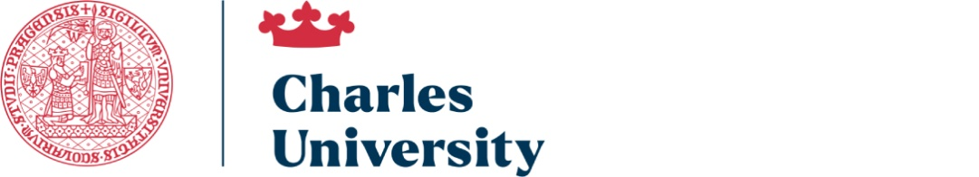
We invite you to participate in the international, interdisciplinary scientific conference entitled "Respect and Stigma in a Divided Society". The aim of the conference is to discuss the manifestations, causes and consequences of the stigmatization in a divided society and the ways to prevent and overcome this phenomenon. We also want to pay equal attention to the issue of respect and recognition, which are not only the opposite of stigma, but also an important condition for the well-being of individuals and communities. Our view will therefore be both negative and positive, in order to facilitate a deeper understanding of the studied phenomena and to facilitate the formulation of corrective strategies.
The conference takes place 60 years after the publication of a key book on this subject, Erving Goffman's “Stigma”. During this period, we have witnessed numerous changes in the stigmatization phenomenon, as well as new concepts and interpretations of it. The conference will therefore be a good opportunity not only to look at the current state of affairs, but also the dynamics of change that led to it.

We are waiting for abstracts with proposals for papers in the following thematic areas:
1. Respect and stigma in public and private life
2. Cross-border stigmatization
3. Dilemmas of research on stigma and respect
4. Respect and stigma in a contemporary culture
5. Anti-stigma potentials of practices involving seniors
6. Anti-stigma practices across divides

On behalf of the scientific committee of the conference:
Dorota Bazuń, Mariusz Kwiatkowski, Martin Strouhal

If you are interested in participating in the conference, please complete the application form below and send it to the following e-mail address no later than 27th October:
M.Kwiatkowski@is.uz.zgora.pl

APPLICATION FORM
- Name:
- Academic degree:
- Affiliation:
- Presentation title:

- Short abstract (no more than 200 words):

DEADLINES
- Sending applications – 27th October, 2023
- Acceptance of applications – 3th November, 2023
- Payment of the conference fee (EUR 200) - 15th November, 2023

Conference participants, after receiving positive reviews, will have the opportunity to publish articles or chapters in selected journals and publishing houses. One of the partner journals is "Adult Education Discourses".
Dyskursy Młodych Andragogów/Adult Education Discourses (uz.zgora.pl)
Other information will be posted on the conference website, which will be launched in the coming days.

